**Program Code –**

import oracledb

oracledb.init_oracle_client(lib_dir=r"C:\app\kotka\product\21c\dbhomeXE\BIN")

conn = oracledb.connect(user="system", password="1606", dsn=None)

cursor = conn.cursor()

print("Connected to Oracle XE (Thick Mode)")

def add_student():

sid = int(input("Enter Student ID: "))

name = input("Enter Student Name: ")

dept = input("Enter Department: ")

cursor.execute("INSERT INTO Student (stud_id, stud_name, dept) VALUES (:1, :2, :3)", (sid, name, dept))

conn.commit()

print("Student Added Successfully")

def view_students():

cursor.execute("SELECT * FROM Student ORDER BY stud_id")

rows = cursor.fetchall()

if not rows:

print("⚠ No Records Found")

else:

print("\n--- Student Records ---")

for r in rows:

print(f"ID: {r[0]}, Name: {r[1]}, Dept: {r[2]}")

def update_student():

sid = int(input("Enter Student ID to Update: "))

new_name = input("Enter New Name: ")

cursor.execute("UPDATE Student SET stud_name=:1 WHERE stud_id=:2", (new_name, sid))

conn.commit()

print("Student Updated Successfully")

def delete_student():

sid = int(input("Enter Student ID to Delete: "))

cursor.execute("DELETE FROM Student WHERE stud_id=:1", (sid,))

conn.commit()

print("Student Deleted Successfully")

# ---------- Menu ----------

while True:

print("\n===== Student Database Menu =====")

print("1. Add Student")

print("2. View Students")

print("3. Update Student")

print("4. Delete Student")

print("5. Exit")

choice = input("Enter choice: ")

if choice == "1":

add_student()

elif choice == "2":

view_students()

elif choice == "3":

update_student()

elif choice == "4":

delete_student()

elif choice == "5":

print("Exiting Program...")

break

else:

print("Invalid Choice. Try Again!")

# ---------- Close Connection ----------

cursor.close()

conn.close()

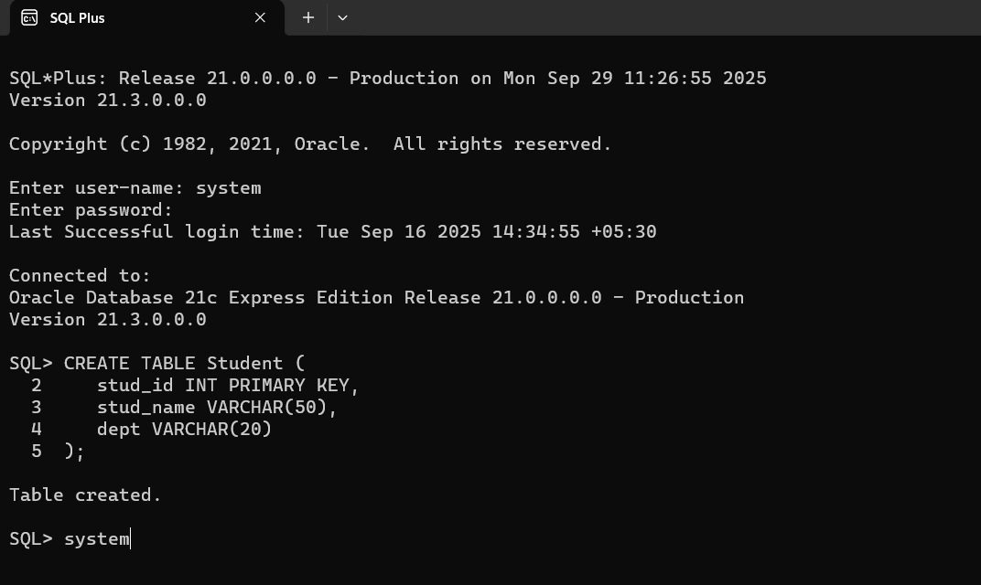

**Output –**

